Programming Language Research Project

Course: CST 8002-040 Programming Languages Research Project
Assignment: Research Assignment 3
Instructor: Tyler DeLay
Student Name: Qinyu Luo
Student ID: 041137796
Due Date: 10/31
Submitted: 10/31

Development Environment Changes
There have been no changes to my development environment since Practical Project Part 2. I continue to use the following configuration:

- Node.js: Version 22.19.0
- Visual Studio Code: Version 1.85.0
- npm: Version 10.9.3

The development environment remains stable and suitable for continuing project development in Practical Project Part 3.

Research and Learning Resources
Advanced Programming Topics Selected:
For Practical Project Part 3, I will enhance my existing data management system from Part 2 by implementing the following three advanced programming topics:
1. User Authentication - Secure access control to protect data operations
2. Database Integration - Migrating from CSV file storage to MongoDB database
3. Multithreading/Concurrency - Improving performance for data-intensive operations

Learning Resources:
User Authentication Resources:
The Node.js official documentation provides comprehensive guides on Express middleware and authentication implementation [1]
Passport.js is the most popular authentication middleware for Node.js, offering complete implementation tutorials for various authentication strategies [2]
MDN Web Docs offers in-depth explanations of JWT (JSON Web Tokens) authentication mechanisms and session management [3]
Database Integration Resources:
MongoDB official tutorials provide detailed instructions on integrating MongoDB with Node.js applications, including connection setup and query operations [4]
Mongoose documentation offers best practices for Object Data Modeling (ODM), schema design, and performing CRUD operations with MongoDB [5]
Concurrency Programming Resources:
Node.js official documentation chapter on Worker Threads explains how to implement multithreading in Node.js applications for CPU-intensive tasks [6]
freeCodeCamp's concurrency programming tutorial provides practical case studies on implementing worker threads for improved application performance [7]

Initial Thoughts on Incorporating Advanced Topics:
User Authentication: I will add a login system with JWT tokens to protect data CRUD operations. Users must authenticate before accessing create, update, and delete functions. This ensures only authorized users can modify the dataset records from Part 2.
Database Integration: I will migrate from CSV file storage to MongoDB. The existing record objects will become MongoDB documents using Mongoose schemas. All CRUD operations will be refactored to perform database queries instead of in-memory array operations, providing better scalability and persistent storage.
Multithreading/Concurrency: I will implement Worker Threads to handle CPU-intensive tasks such as bulk data processing and CSV-to-MongoDB migration. This prevents the main thread from blocking and keeps the web server responsive during heavy operations.
These three features will transform my basic data management system from Part 2 into a production-ready web application with secure authentication, persistent database storage, and optimized performance.

Work Breakdown Structure for Practical Project Part 3
1. Project Planning and Design
1.1 Requirements Analysis and Documentation
1.2 System Architecture Design
1.3 Database Schema Design

2. Development Environment Setup
2.1 Install and Configure Node.js Dependencies
2.2 Configure MongoDB Database
2.3 Setup Development Tools and Testing Environment

3. Data Migration
3.1 Design MongoDB Schema Based on CSV Structure
3.2 Create Data Migration Scripts
3.3 Migrate Existing CSV Data to MongoDB

4. Database Integration Implementation
4.1 Implement Database Connection and Models
4.2 Refactor CRUD Operations to Use Database
4.3 Update File-IO Logic for Database Operations

5. User Authentication Implementation
5.1 Develop User Registration Feature
5.2 Develop User Login and JWT Authentication
5.3 Implement Protected Routes and Middleware
5.4 Add Authorization to CRUD Operations

6. Concurrency Features Implementation
6.1 Implement Worker Threads for Data Processing
6.2 Optimize Bulk Data Operations
6.3 Implement Background Task Processing

7. Testing and Debugging
7.1 Unit Testing for Authentication
7.2 Unit Testing for Database Operations
7.3 Integration Testing
7.4 Performance Testing
7.5 Bug Fixes

8. Documentation
8.1 Update Code Comments
8.2 Update README with New Features
8.3 Write Technical Documentation

9. Project Delivery (Milestone)
9.1 Final Code Submission
9.2 Project Demonstration Preparation

Gantt Chart
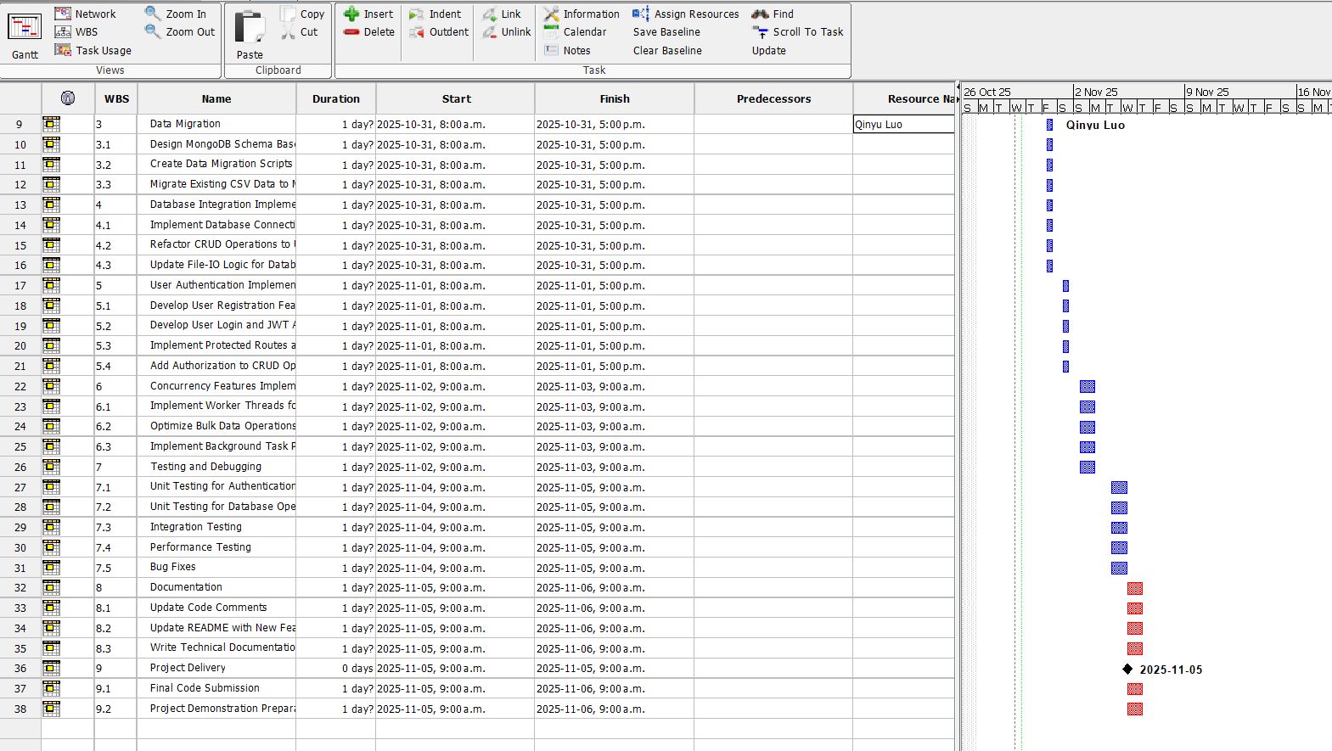
Based on the WBS above, I have created a Gantt chart using ProjectLibre. The chart includes all tasks with time estimates in days, sequential tasks are linked, sub-tasks are indented, and my full name appears as a resource. A milestone for "Practical Project Part 3 Delivered" is set on the due date.

References

[1] | U. middleware. [Online]. Available: https://expressjs.com/zh-cn/guide/using-middleware.html#. [Accessed 29 10 2025].
[2] | "Middleware," [Online]. Available: https://www.passportjs.org/concepts/authentication/middleware/. [Accessed 29 10 2025].
[3] | "HTTP authentication," [Online]. Available: https://developer.mozilla.org/en-US/docs/Web/HTTP/Guides/Authentication. [Accessed 29 10 2025].
[4] | "Using MongoDB with Node.js," [Online]. Available: https://www.mongodb.com/resources/languages/mongodb-with-nodejs. [Accessed 29 10 2025].
[5] | "Tutorial: Get Started with Mongoose," [Online]. Available: https://www.mongodb.com/docs/drivers/node/current/integrations/mongoose-get-started/. [Accessed 29 10 2025].
[6] | "Node.js v13.1.0 Documentation," [Online]. Available: https://nodejs.org/download/release/v13.1.0/docs/api/worker_threads.html. [Accessed 29 10 2025].
[7] | S. Saha, "How to Implement Multi-Threading in Node.js With Worker Threads [Full Handbook]," [Online]. Available: https://www.freecodecamp.org/news/how-to-implement-multi-threading-in-nodejs-with-worker-threads-full-handbook/. [Accessed 29 10 2025].

